**Madiha Aimon Tappal**

[madihaaimon@gmail.com](mailto:madihaaimon@gmail.com)

**Data Engineering Batch – 1**

**Azure Devops Coding**

1. **Create Azure Devops Environment and configuring Azure Devops Git Repository ,configure on your local git to implement this upload few test files on same.**

**What is Azure Devops?**

Azure DevOps is a suite of tools that helps organizations deliver software faster and with more quality. It provides a comprehensive set of features for version control, continuous integration and continuous delivery (CI/CD), build automation, testing, and release management.

[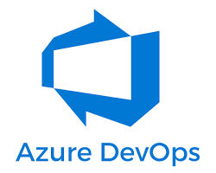 w](https://medium.com/featurepreneur/what-is-azure-devops-863698ae986f)

Azure DevOps logo

Here are some of the key benefits of using Azure DevOps:

* **Improved collaboration:** Azure DevOps provides a central platform for developers, testers, and operations teams to collaborate on software development. This helps to break down silos and improve communication between teams.
* **Faster software delivery:** Azure DevOps automates many of the tasks involved in software development, such as building, testing, and deployment. This can help organizations to deliver software faster and more frequently.
* **Higher quality software:** Azure DevOps provides tools for continuous testing and integration, which can help to identify and fix bugs early in the development process. This can lead to higher quality software releases.

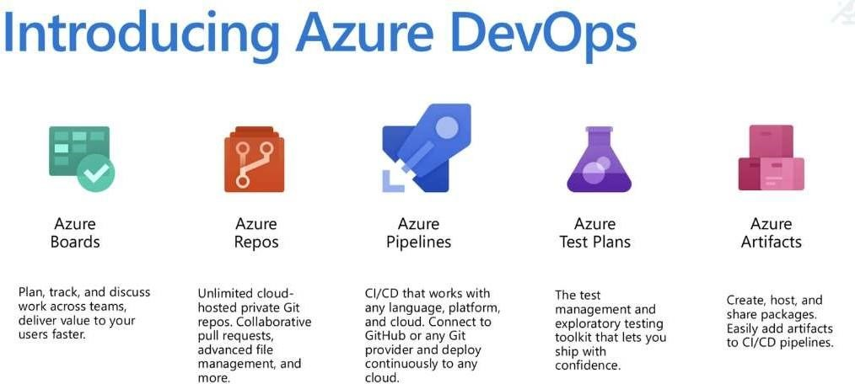

**What technologies do I need to support DevOps?**

DevOps brings together people, processes, and technology, automating software delivery to provide continuous  value to your users. Using Azure DevOps, you can deliver software faster and more reliably - no matter how big  your IT department or what tools you’re using.

**Continuous Integration (CI)**

* Improve software development  quality and speed.
* When you use Azure Pipelines or  Jenkins to build apps in the cloud and  deploy to Azure, each time you

commit code, it’s automatically built  and tested and bugs are detected  faster.

**Continuous Deployment (CD)**

* By combining continuous integration  and infrastructure as code (IaC), you’ll  achieve identical deployments and  the confidence to deploy to  production at any time.
* With continuous deployment, you can  automate the entire process from  code commit to production if your  CI/CD tests are successful.

**Continuous Learning & Monitoring**

* With Azure Application Insights you  can identify how your applications are  performing and test if the recent  deployment made things better or  worse.
* Using CI/CD practices, paired with  monitoring tools, you’ll be able to safely  deliver features to your customers as  soon as they’re ready.

**Azure Repos:**

* **The secure home for your code and project assets.**
* **Unlimited private Git repositories:** Host your codebase and collaborate with your team using branching, pull requests, and code reviews.
* **Version control:** Track changes, revert to previous versions if needed, and maintain a clear history of your project's evolution.
* **Integrations:** Connect with Pipelines for automated builds and deployments based on code changes.

Azure Repos, formerly known as Visual Studio Team Services (VSTS) Git repositories, offers a robust platform for version control and code collaboration. To answer your question about the "full theory" of Azure Repos, I'll break it down into key aspects:

**Concept and Functionality:**

* **Git-based:** Azure Repos leverages Git, a popular distributed version control system (DVCS). This means each developer has a complete copy of the codebase, enabling offline work and efficient branching and merging.
* **Version Control:** Track changes, revert to previous versions, and identify who made modifications with detailed history.
* **Code Collaboration:** Share code, create pull requests for review, and discuss changes through comments and threads.
* **Security and Access Control:** Define granular permissions for different users and teams, ensuring code security and access control.
* **Integrations:** Seamlessly integrate with other Azure DevOps services like Azure Pipelines for automated builds, testing, and deployments, and Azure Boards for project management and task tracking.

**Benefits and Features:**

* **Free private repositories:** Host unlimited private Git repositories for free with basic features.
* **Enhanced security:** Benefit from robust security features like role-based access control, two-factor authentication, and encryption.
* **Scalability:** Accommodate large projects and teams with ease.
* **Rich integrations:** Streamline your development workflow with seamless integration across Azure DevOps services.
* **Advanced features:** Utilize features like branch policies, code search, and continuous integration/continuous delivery (CI/CD) pipelines for efficient development.

**Learning Resources:**

* **Microsoft Documentation:** <https://learn.microsoft.com/en-us/azure/devops/repos/?view=azure-devops>
* **Azure Repos Tutorial:** <https://www.techtarget.com/searchcloudcomputing/tutorial/An-Azure-Repos-tutorial-to-build-a-container-image>
* **Azure DevOps Website:** <https://learn.microsoft.com/en-us/azure/devops/repos/?view=azure-devops>

**Beyond the Basics:**

While the above covers the core functionalities, Azure Repos offers deeper capabilities for advanced users and specific workflows:

* **Pull request reviews:** Utilize code review tools and workflows for in-depth code analysis and feedback.
* **Branching strategies:** Implement efficient branching strategies like Gitflow or feature branching to manage complex development cycles.
* **Continuous integration/continuous delivery (CI/CD):** Automate build, test, and deployment processes with Azure Pipelines for faster and more reliable software delivery.
* **Large file support:** Manage large files efficiently with Git LFS integration.

**Azure DevOps Services | Azure DevOps Server 2022 - Azure DevOps Server 2019 | TFS 2018**

Azure Repos offers free unlimited private Git repositories, making it easy to try. Git is the most commonly used version control system today and is quickly becoming the standard for version control. It is a distributed version control system, meaning that your local copy of code is a complete version control repository. These fully functional local repositories make it easy to work offline or remotely. You can commit your work locally, and then sync your copy of the repository with the copy on the server.

**Key concepts**

* [Branches & branch policies](https://learn.microsoft.com/en-us/azure/devops/repos/git/branch-policies-overview?view=azure-devops)
* [Branch organization](https://learn.microsoft.com/en-us/azure/devops/repos/git/git-branching-guidance?view=azure-devops)
* [Forks](https://learn.microsoft.com/en-us/azure/devops/repos/git/forks?view=azure-devops)
* [History](https://learn.microsoft.com/en-us/azure/devops/repos/git/history?view=azure-devops)
* [Pull requests](https://learn.microsoft.com/en-us/azure/devops/repos/git/pull-requests?view=azure-devops)

**Git**

Git is the most commonly used version control system today and is quickly becoming the standard for version control. Git is a distributed version control system, meaning that your local copy of code is a complete version control repository. These fully functional local repositories make it easy to work offline or remotely. You commit your work locally, and then sync your copy of the repository with the copy on the server.

Git in Azure Repos is standard Git. You can use the clients and tools of your choice, such as Git for Windows, Mac, partners' Git services, and tools such as Visual Studio and Visual Studio Code.

* [Connect your favorite development environment](https://learn.microsoft.com/en-us/azure/devops/repos/get-started/what-is-repos?view=azure-devops#connect-your-favorite-development-environment)
* [Review code with pull requests](https://learn.microsoft.com/en-us/azure/devops/repos/get-started/what-is-repos?view=azure-devops#review-code-with-pull-requests)
* [Protect branches with policies](https://learn.microsoft.com/en-us/azure/devops/repos/get-started/what-is-repos?view=azure-devops#protect-branches-with-policies)
* [Extend pull request workflows with pull request status](https://learn.microsoft.com/en-us/azure/devops/repos/get-started/what-is-repos?view=azure-devops#extend-pull-request-workflows-with-pull-request-status)
* [Isolate code with forks](https://learn.microsoft.com/en-us/azure/devops/repos/get-started/what-is-repos?view=azure-devops#isolate-code-with-forks)

**Connect your favorite development environment**

Connect your favorite development environment to Azure Repos to access your repos and manage your work. Share your code using:

* [Command-line](https://learn.microsoft.com/en-us/azure/devops/repos/git/share-your-code-in-git-cmdline?view=azure-devops)
* [Visual Studio Code](https://marketplace.visualstudio.com/vscode)
* [Visual Studio](https://learn.microsoft.com/en-us/azure/devops/repos/git/share-your-code-in-git-vs?view=azure-devops)
* [Xcode](https://learn.microsoft.com/en-us/azure/devops/repos/git/share-your-code-in-git-xcode?view=azure-devops)
* [Eclipse](https://learn.microsoft.com/en-us/previous-versions/azure/devops/all/java/download-eclipse-plug-in)
* [IntelliJ](https://learn.microsoft.com/en-us/previous-versions/azure/devops/all/java/download-intellij-plug-in)

**Review code with pull requests**

Review code with your team and make sure that changes build and pass tests before it gets merged.

* [Create a pull request](https://learn.microsoft.com/en-us/azure/devops/repos/git/pull-requests?view=azure-devops)
* [Link work items to pull requests](https://learn.microsoft.com/en-us/azure/devops/repos/git/pull-requests?view=azure-devops#link-work-items)
* [Set up branch policies](https://learn.microsoft.com/en-us/azure/devops/repos/git/branch-policies?view=azure-devops#build-validation)
* [Squash merge pull requests](https://learn.microsoft.com/en-us/azure/devops/repos/git/merging-with-squash?view=azure-devops)
* [Git branch and pull request workflows](https://learn.microsoft.com/en-us/azure/devops/repos/git/git-branching-guidance?view=azure-devops)
* [Leave comments or vote on changes](https://learn.microsoft.com/en-us/azure/devops/repos/git/review-pull-requests?view=azure-devops)

**Extend pull request workflows with pull request status**

Pull requests and branch policies enable teams to enforce many best practices related to reviewing code and running automated builds. But many teams have other requirements and validations to perform on code. To cover these individual and custom needs, Azure Repos offers pull request statuses.

Pull request statuses integrate into the PR workflow. They allow external services to programmatically sign off on a code change by associating simple success/failure information with a pull request.

* [Pull request status overview](https://learn.microsoft.com/en-us/azure/devops/repos/git/pull-request-status?view=azure-devops)
* [Create a PR status server with Node.js](https://learn.microsoft.com/en-us/azure/devops/repos/git/create-pr-status-server?view=azure-devops)
* [Use Azure Functions to create custom branch policies](https://learn.microsoft.com/en-us/azure/devops/repos/git/create-pr-status-server-with-azure-functions?view=azure-devops)
* [Configure a branch policy for an external service](https://learn.microsoft.com/en-us/azure/devops/repos/git/pr-status-policy?view=azure-devops)

1. **Install Git command-line tools**

Install one of the following Git command-line tools:

* [Git for Windows and Git Credential Manager](https://learn.microsoft.com/en-us/azure/devops/repos/git/set-up-credential-managers?view=azure-devops).
* To install on macOS or Linux, check out the [Installing Git](https://git-scm.com/book/en/v2/Getting-Started-Installing-Git) chapter in the open-source *Pro Git* book. For macOS and Linux, we recommend that you [configure SSH authentication](https://learn.microsoft.com/en-us/azure/devops/repos/git/use-ssh-keys-to-authenticate?view=azure-devops).

**2. Clone the repo to your computer**

To work with a Git repo, clone it to your computer, which creates a complete local copy of the repo. Your code might be in one of several places.

1. Complete the following step that's applicable to your scenario:
   * If **You don't have any code yet**, first [Create a new Git repo in your project](https://learn.microsoft.com/en-us/azure/devops/repos/git/create-new-repo?view=azure-devops#create-a-repo-using-the-web-portal), and then complete the next step.
   * If **the code is in another Git repo**, such as a GitHub repo or a different Azure Repo instance, [import it into a new or existing empty Git repo](https://learn.microsoft.com/en-us/azure/devops/repos/git/import-git-repository?view=azure-devops), and then complete the next step.
   * If **the code is on your local computer and not yet in version control**, either [create a new Git repo in your project](https://learn.microsoft.com/en-us/azure/devops/repos/git/create-new-repo?view=azure-devops#create-a-repo-using-the-web-portal) or add your code to an existing repository.
2. From your web browser, open the team project for your organization and select **Repos** > **Files**.

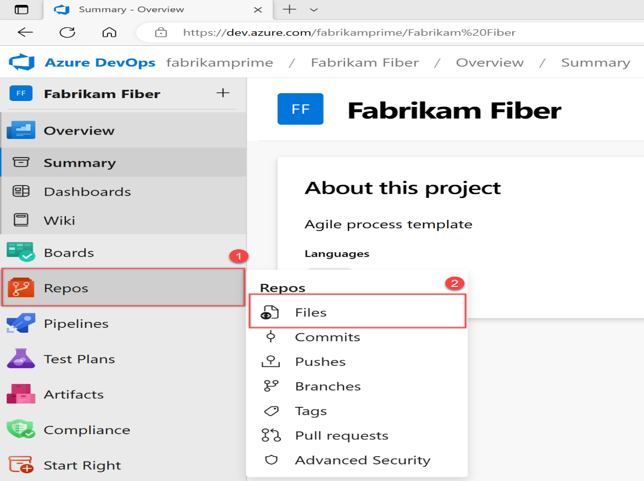

1. Select **Clone** in the upper-right corner of the **Code** window and copy the URL.

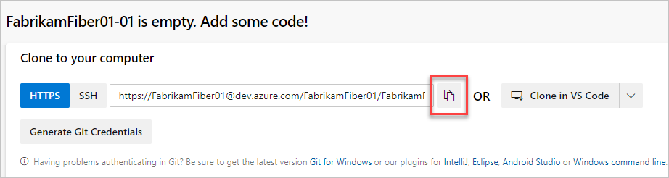

1. Open the Git command window (Git Bash on Git for Windows). Go to the folder where you want the code from the repo stored on your computer, and run git clone, followed by the path copied from **Clone URL** in the previous step. See the following example:

Copy

git clone https://FabrikamFiber01@dev.azure.com/FabrikamFiber01/FabrikamFiber01-01/_git/FabrikamFiber01-01

Git downloads a copy of the code, including all [commits](https://learn.microsoft.com/en-us/azure/devops/repos/git/commits?view=azure-devops), and [branches](https://learn.microsoft.com/en-us/azure/devops/repos/git/branch-policies-overview?view=azure-devops) from the repo, into a new folder for you to work with.

1. Switch your directory to the repository that you cloned.

Copy

cd fabrikam-web

Keep this command window open to work in a branch.

**3. Work in a branch**

Git [branches](https://learn.microsoft.com/en-us/azure/devops/repos/git/branch-policies-overview?view=azure-devops) isolate your changes from other work being done in the project. We recommend using the [Git workflow](https://learn.microsoft.com/en-us/azure/devops/repos/git/gitworkflow?view=azure-devops), which uses a new branch for every feature or fix that you work on. For our examples, we use the branch, users/jamal/feature1.

1. Create a branch with the branch command.

Copy

git branch users/jamal/feature1

This command creates a reference in Git for the new branch. It also creates a pointer back to the parent commit so Git can keep a history of changes as you add commits to the branch.

If you're working with a previously cloned repository, ensure that you've checked out the right branch (git checkout main) and that it's up to date (git pull origin main) before you create your new branch.

1. Use checkout to switch to that branch.

Copy

git checkout users/jamal/feature1

Git changes the files on your computer to match the latest commit on the checked-out branch.

Copy

git checkout main

git pull origin main

git branch users/jamal/feature1

git checkout users/jamal/feature1

You can replace the first three commands in the previous example with the following command, which creates a new branch named users/jamal/feature1 based on the latest main branch.

Copy

git pull origin main:users/jamal/feature1

Switch back to the Git Bash window that you used in the previous section. Run the following commands to create and check out a new branch based on the main branch.

Copy

git pull origin main:users/jamal/feature1

git checkout feature1

**4. Work with the code**

In the following steps, we make a change to the files on your computer, commit the changes locally, and then push the commit to the repo stored on the server.

1. Browse to the folder on your computer where you cloned the repo, open the README.md file in your editor of choice, and make some changes. Then, **Save** and close the file.
2. In the Git command window, go to the contoso-demo directory by entering the following command:

Copy

cd contoso-demo

1. Commit your changes by entering the following commands in the Git command window:

Copy

git add .

git commit -m "My first commit"

The git add . command stages any new or changed files, and git commit -m creates a commit with the specified commit message.

Check which branch you're working on before you commit, so that you don't commit changes to the wrong branch. Git always adds new commits to the current local branch.

1. Push your changes to the Git repo on the server. Enter the following command into the Git command window:

Copy

git push origin users/jamal/feature1

Your code is now shared to the remote repository, in a branch named users/jamal/feature1. To merge the code from your working branch into the main branch, use a pull request.

**5. Merge your changes with a pull request**

Pull requests combine the review and merge of your code into a single collaborative process. After you’re done fixing a bug or new feature in a branch, create a new pull request. Add the members of the team to the pull request so they can review and vote on your changes. Use pull requests to review works in progress and get early feedback on changes. There’s no commitment to merge the changes because you can abandon the pull request at any time.

The following example shows the basic steps of creating and completing a pull request.

1. Open the team project for your organization in your web browser and select **Repos** > **Files**. If you kept your browser open after getting the clone URL, you can just switch back to it.
2. Select **Create a pull request** in the upper-right corner of the **Files** window. If you don't see a message like **You updated users/jamal/feature1 just now**, refresh your browser.

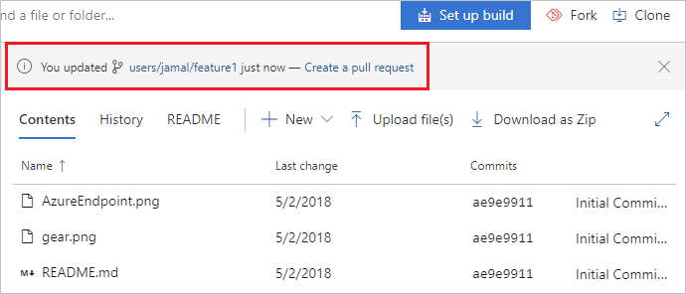

New pull requests are configured to merge your branch into the default branch, which in this example is main. The title and description are prepopulated with your commit message.

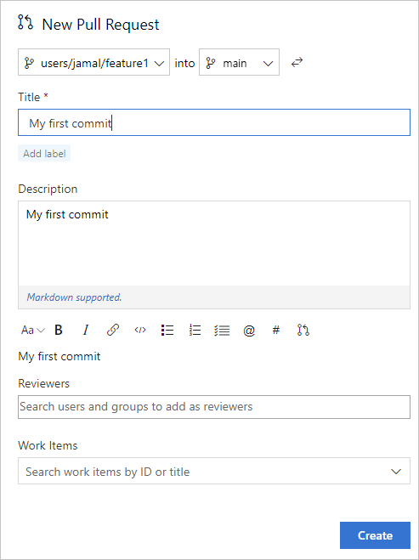

You can [add reviewers](https://learn.microsoft.com/en-us/azure/devops/repos/git/pull-requests?view=azure-devops#add-and-remove-reviewers) and [link work items](https://learn.microsoft.com/en-us/azure/devops/repos/git/pull-requests?view=azure-devops#link-work-items) to your pull request.

You can review the files included in the pull request at the bottom of the **New Pull Request** window.

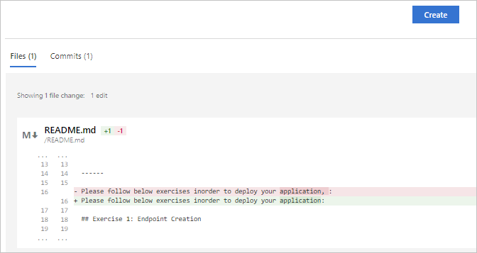

1. Select **Create**.

View the details of your pull request from the **Overview** tab. You can also view the changed files, updates, and commits in your pull request from the other tabs.

1. Select **Complete** to begin the process of completing the pull request.
2. Select **Complete merge** to complete the pull request and merge your code into the main branch.

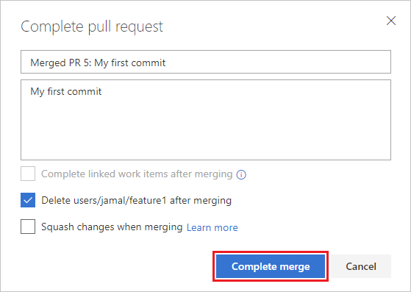

**Note**

This example shows the basic steps of creating and completing a pull request. For more information, see [**Create, view, and manage pull requests**](https://learn.microsoft.com/en-us/azure/devops/repos/git/pull-requests?view=azure-devops).

Your changes are now merged into the main branch, and your users/jamal/feature1 branch is deleted on the remote repository.

**View history**

1. Switch back to the web portal and select **History** from the **Code** page to view your new commit.

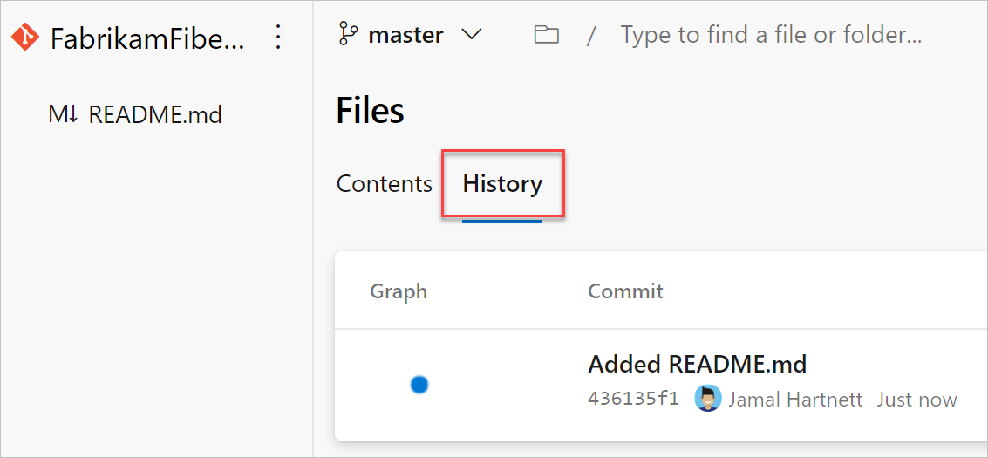

1. Switch to the **Files** tab, and select the README file to view your changes.

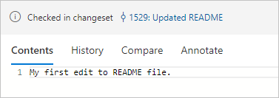

**Clean up**

Switch back to your Git Bash command prompt and run the following command to delete your local copy of the branch.

Copy

git checkout main

git pull origin main

git branch -d users/jamal/feature1

This action completes the following tasks:

* The git checkout main command switches you to the main branch.
* The git pull origin main command pulls down the latest version of the code in the main branch, including your changes and the fact that users/jamal/feature1 was merged.
* The git branch -d users/jamal/feature1 command deletes your local copy of that branch.

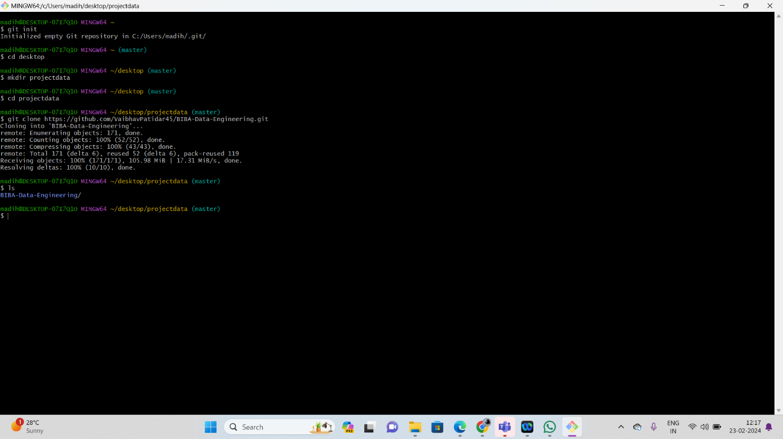

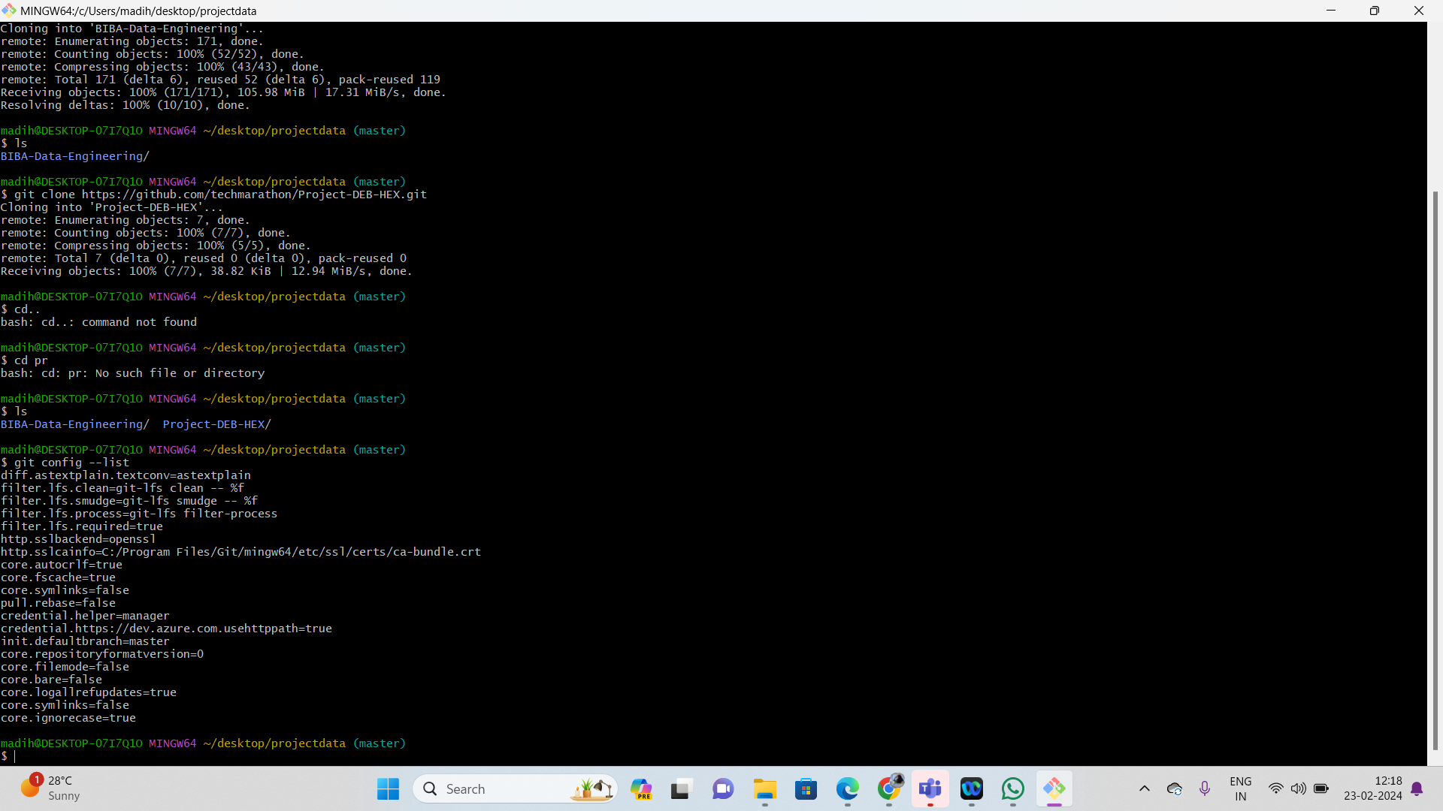

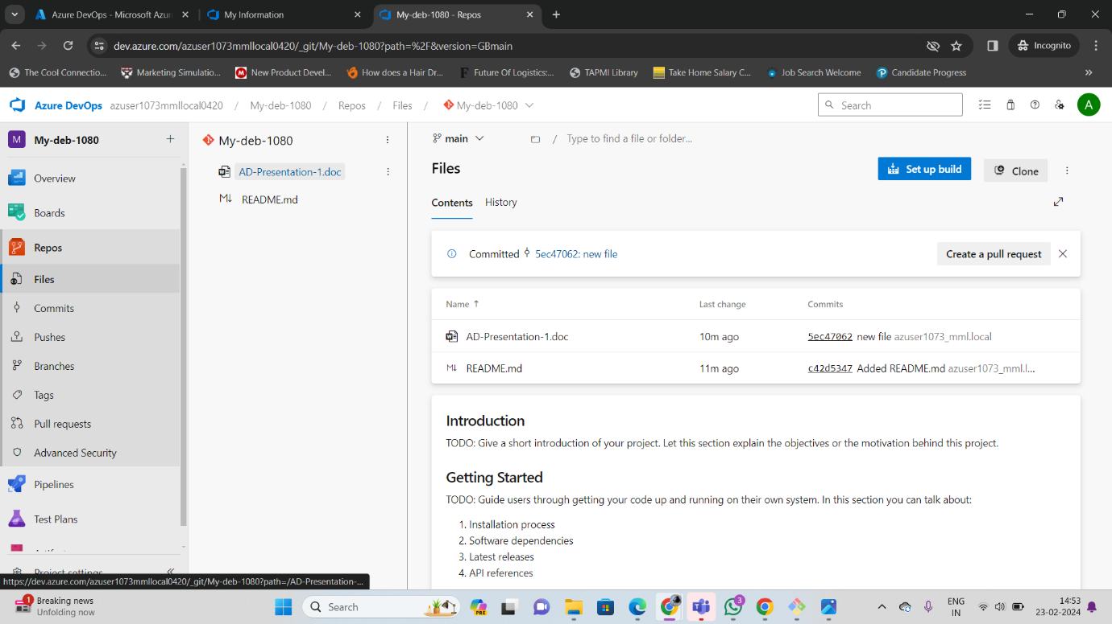

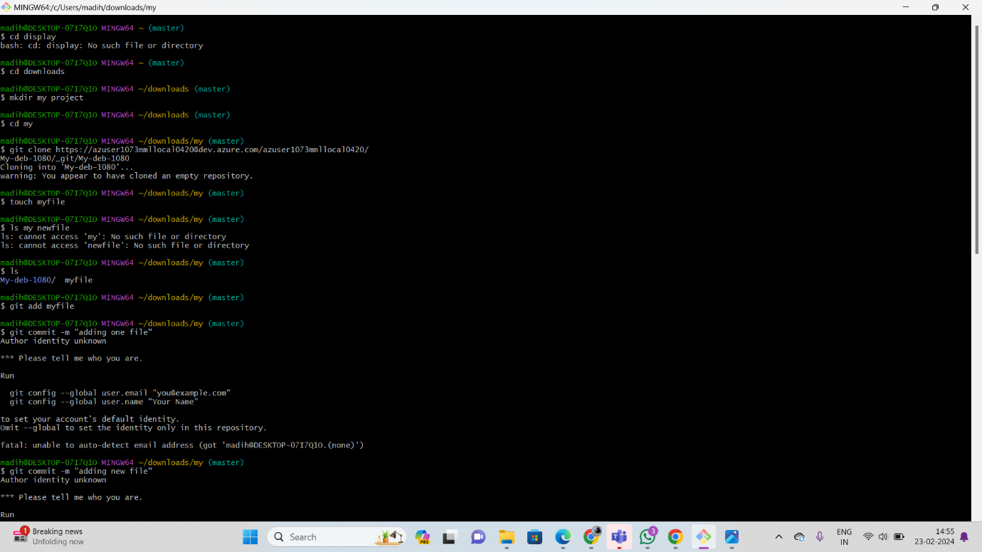

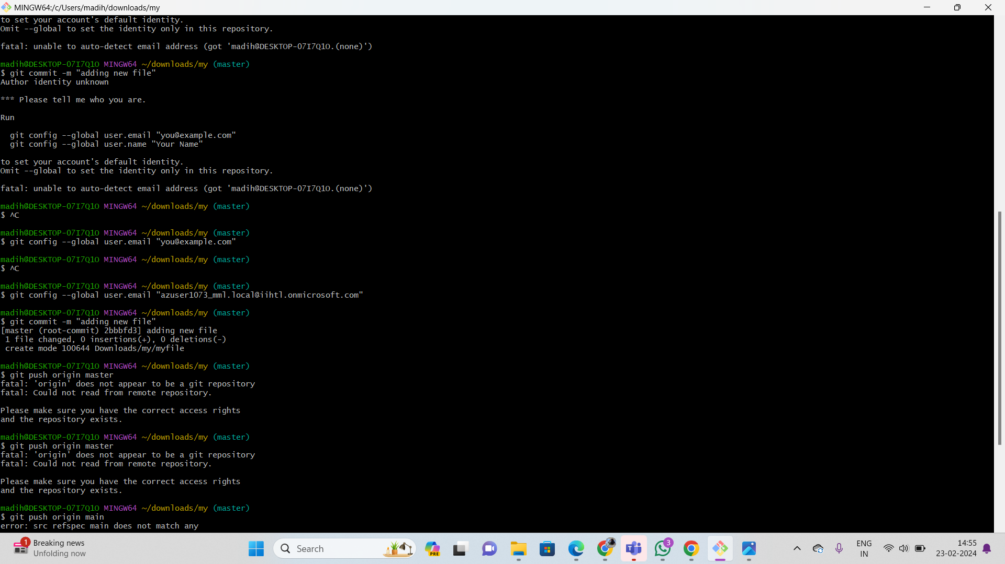

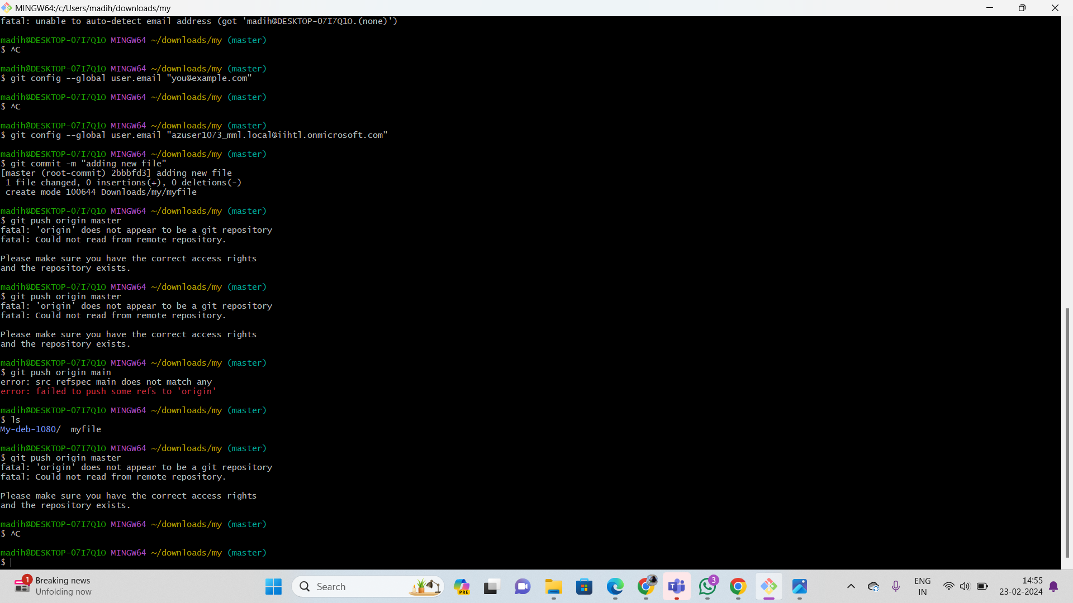

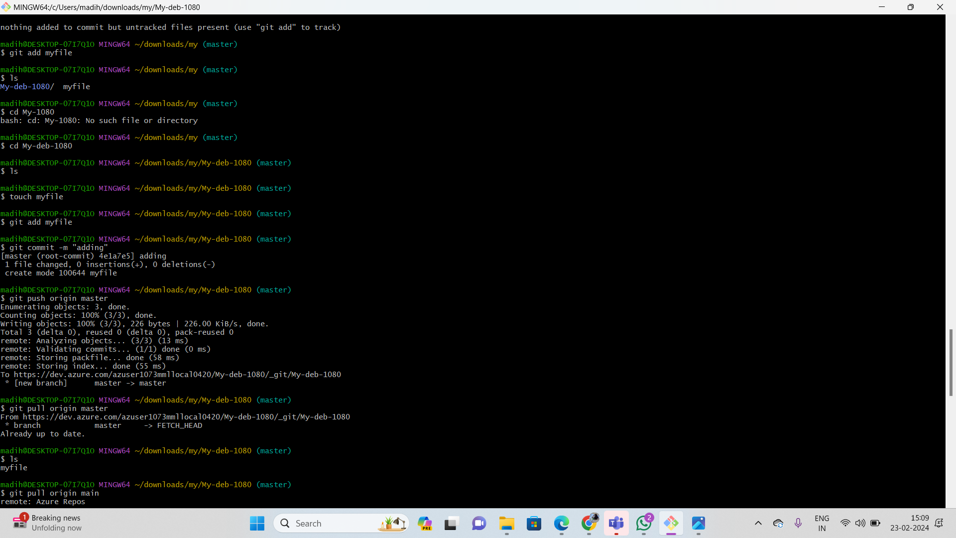

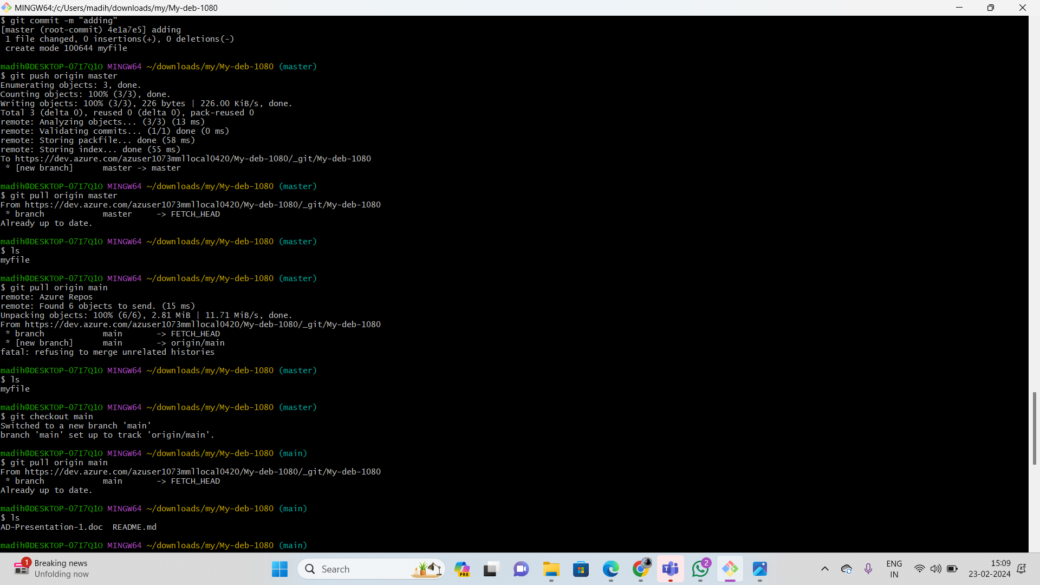

1. **Leverage the practises of CICD Using azure Dataengineering and explain the architecture of the Azure synpase .**

**What is CI/CD?**

CI/CD stands for **Continuous Integration and Continuous Delivery/Deployment**. It's a set of practices that aim to automate the software development lifecycle, from code changes to deployment in production. Here's a breakdown of the two key components:

**Continuous Integration (CI)** involves frequently merging code changes from multiple developers into a shared repository. This happens automatically, often triggered by events like code commits. Each merge is then followed by an automated build and test process. This helps to catch bugs early on and ensure that the codebase remains stable and functional.

[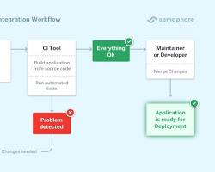w](https://semaphoreci.com/continuous-integration)

Continuous Integration

**Continuous Delivery (CD)** focuses on automating the delivery of code changes to different environments, such as testing, staging, and production. This allows for faster feedback and quicker releases. In some cases, CD can even involve **Continuous Deployment**, where every code change that passes the tests is automatically deployed to production.

[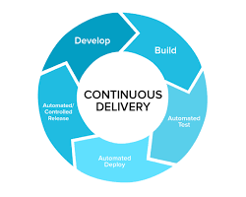w](https://www.altexsoft.com/blog/continuous-delivery-and-integration-rapid-updates-by-automating-quality-assurance/)

Continuous Delivery

**Benefits of CI/CD:**

* **Faster feedback:** With CI/CD, developers can get feedback on their code changes quickly, which helps them identify and fix bugs early on.
* **Improved quality:** By automating the build and test process, CI/CD helps to ensure that code is always of high quality.
* **Reduced risk:** By automating deployments, CI/CD helps to reduce the risk of human error and ensures that deployments are consistent and reliable.
* **Faster releases:** By streamlining the development process, CI/CD can help teams release new features and updates more frequently.

Overall, CI/CD is a powerful set of practices that can help software development teams to be more efficient, productive, and deliver higher quality software.

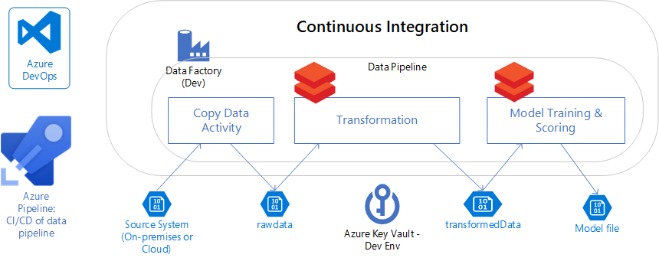

**CI/CD in data pipelines**

CI/CD, in the context of data pipeline deployment, focuses on automating data operations and transformations.

This merges development, testing, and operational workflows into a unified, automated process, ensuring that data assets are consistently high quality and that data infrastructure evolves smoothly, even at scale.

Using CI/CD for data pipeline automation has become more critical in ensuring the development velocity of processes such as training machine learning models, supporting a data science team, doing large-scale data analysis, business intelligence or data visualization, supporting the growth of unstructured data collection, and other business needs. For example, as organizations adopt a data mesh approach, more structured and trackable deployment becomes more vital.

Continuous integration and continuous deployment both have a set of characteristics that we need to understand to design an effective process:

**Continuous Integration (CI) in data pipelines**

**Automated Testing**

Automated tests check the integrity and quality of data transformations, ensuring that data is processed as expected and any error is spotted early.

**Version Control**

Data pipeline code (e.g., SQL scripts, Python transformations) is stored in repositories like Git, allowing tracking and managing changes.

**Consistent Environment**

CI tools can run tests in environments that mirror production, ensuring that differences in configuration or dependencies don't introduce errors.

**Data Quality Checks**

These might include checks for null values, data range violations, data type mismatches, or other custom quality rules.

**CI/CD in Azure Data Engineering**

CI/CD (Continuous Integration and Continuous Delivery/Deployment) is crucial in data engineering. It streamlines development, assures code quality, and enables rapid, reliable updates to your data pipelines. Here's how to implement it in the Azure ecosystem:

1. **Source Control:**
   * **Azure Repos (Git):** Ideal for versioning data engineering artifacts (ETL scripts, notebooks, configuration files).
   * Ensure proper branching and merge strategies.
2. **Build Pipelines:**
   * **Azure Pipelines:** Used for:
     + **Compiling Code:** If you are using languages like Python or Scala.
     + **Testing:** Implement unit and integration tests to validate your data transformation logic.
     + **Packaging Artifacts:** Bundle code and dependencies for deployment.
3. **Release Pipelines:**
   * **Azure Pipelines:** Automate deployment across environments:
     + **Development:** For initial testing.
     + **Staging:** For broader testing and validation.
     + **Production:** For final rollout of pipelines.
   * **Leverage Gates:** Include approval processes and quality checks before promotion to higher environments.

**CI/CD Workflow Example**

1. Data engineers develop code changes in their local environment and push to a feature branch in Azure Repos.
2. This triggers an Azure Pipeline build: validating code, running tests.
3. If successful, a deployment package is generated.
4. Release pipeline is triggered, deploying to development, then potentially staging (after approvals), and finally production environments.

**Azure Synapse Analytics Architecture**

**Azure Synapse:**

Azure Synapse Analytics is a comprehensive cloud-based analytics service that integrates various data processing and analytics technologies to enable organizations to derive valuable insights from large volumes of data. It is designed to handle both traditional structured data and unstructured big data, providing a unified platform for data storage, processing, and analysis. Here are some key theoretical aspects of Azure Synapse Analytics:

1. **Unified Analytics Platform:**
   * Azure Synapse Analytics integrates data warehouse capabilities with big data processing. It unifies these traditionally separate systems into a single platform, allowing users to seamlessly analyze and visualize data from different sources.
2. **Data Integration:**
   * The service supports data integration from diverse sources, whether they are on-premises or in the cloud. It facilitates the extraction, transformation, and loading (ETL) processes to ensure that data is prepared for analysis.
3. **Data Warehousing:**
   * Azure Synapse Analytics serves as a data warehousing solution, providing a scalable and performant repository for structured data. Users can organize and store large volumes of data in a way that is optimized for analytics and reporting.
4. **Big Data Processing:**
   * The platform supports big data processing using Apache Spark, enabling users to analyze and derive insights from unstructured or semi-structured data. This is particularly useful for scenarios where traditional relational databases may not be the most efficient.
5. **Real-Time Analytics:**
   * Azure Synapse Analytics enables real-time analytics by supporting the processing of streaming data alongside batch data. This capability is crucial for organizations that need to make decisions based on up-to-the-minute information.
6. **Scalability and Performance:**
   * The service is designed to scale horizontally to handle growing amounts of data and increasing processing demands. It provides performance optimizations, such as distributed query processing, to deliver fast query results even for large datasets.
7. **Security and Compliance:**
   * Azure Synapse Analytics places a strong emphasis on security, offering features such as data encryption, identity and access management, and compliance with industry standards. This ensures that sensitive data is protected and that the platform meets regulatory requirements.
8. **Data Exploration and Visualization:**
   * Users can explore and visualize their data using various tools, including integration with Power BI. This empowers analysts and decision-makers to interact with data in a way that is meaningful and aids in the decision-making process.

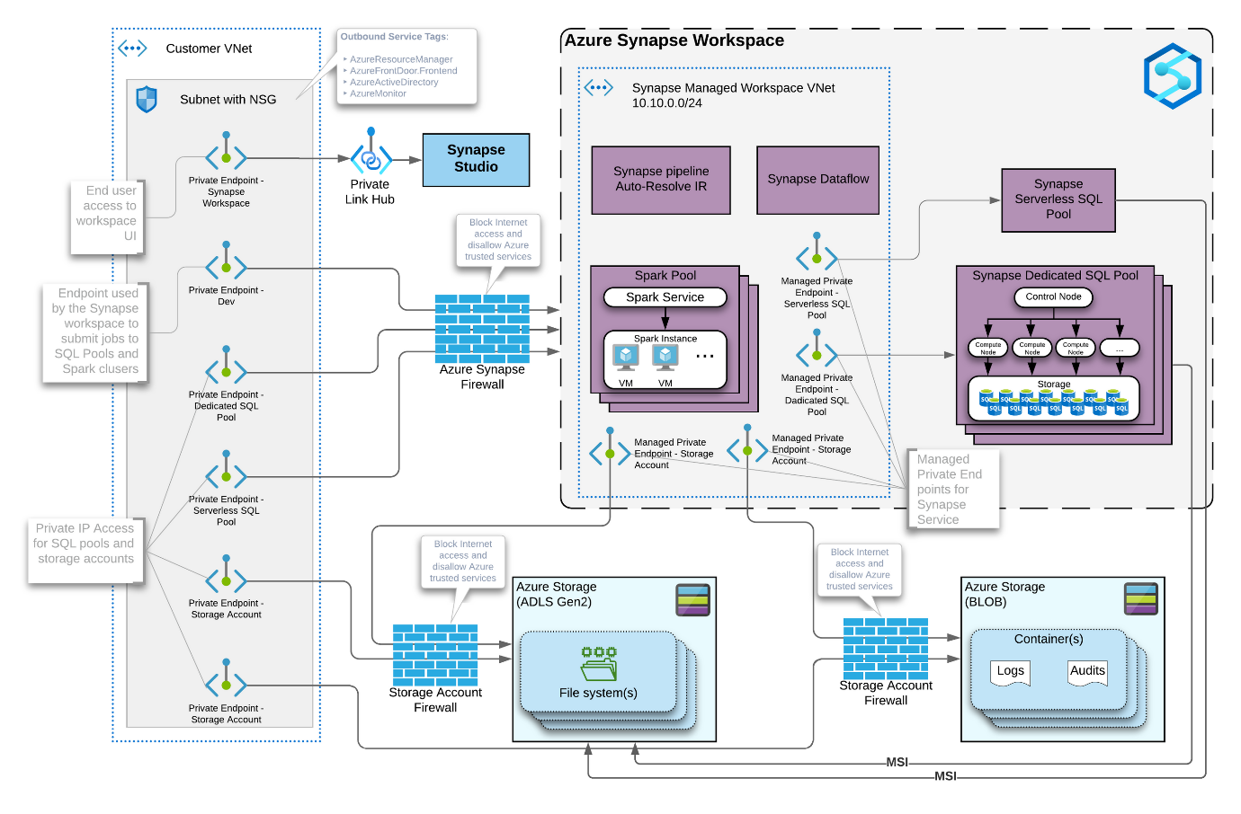

In summary, Azure Synapse Analytics provides a versatile and integrated analytics platform that brings together data warehousing and big data processing capabilities. Its unified approach aims to simplify the analytics workflow and support organizations in gaining actionable insights from their data.

Azure Synapse Analytics offers several advantages and use cases, making it a powerful platform for organizations looking to analyze and derive insights from their data. Here are some key advantages and common usage scenarios:

**Advantages:**

1. **Unified Analytics Platform:**
   * **Advantage:** Provides a single platform for both data warehousing and big data analytics, simplifying the analytics architecture and reducing the need for multiple tools.
2. **Scalability:**
   * **Advantage:** Offers elastic scalability, allowing organizations to scale resources up or down based on demand. This ensures optimal performance even as data volumes grow.
3. **Performance Optimization:**
   * **Advantage:** Utilizes distributed query processing and optimization techniques to deliver fast query results, enabling users to analyze large datasets efficiently.
4. **Data Integration:**
   * **Advantage:** Supports seamless integration of data from various sources, both structured and unstructured, enabling comprehensive analysis.
5. **Real-Time Analytics:**
   * **Advantage:** Enables real-time analytics by processing streaming data alongside batch data, allowing organizations to make decisions based on the most up-to-date information.

Azure Synapse Analytics offers a unified analytics platform for large-scale data warehousing and big data processing. Key components include:

* **Provisioned SQL Pools (formerly SQL Data Warehouse):**
  + Relational data warehouse optimized for analytical queries.
  + Stores data in columnar format.
  + Leverages Massively Parallel Processing (MPP) architecture for distributed query execution.
* **Serverless SQL Pools:**
  + For ad-hoc querying of data residing in Azure Data Lake Storage.
  + Pay-per-query model.
* **Apache Spark Pools:**
  + Large-scale in-memory data processing for complex transformations, machine learning, and streaming analytics.
* **Pipelines:**
  + Visual orchestration engine to design data pipelines.
  + Integration with Azure Data Factory (ADF) components.
* **Synapse Studio:**
  + Unified workspace for development, monitoring, management, and collaboration.

**Deeper Dive into Azure Synapse Analytics Architecture:**

**1. Scale-Out Architecture:**

* Employs a **"shared-nothing" architecture**. Each node has its own CPU, memory, and storage, enabling independent scaling of compute and storage resources.
* **Control Node:** Single entry point for user connections and T-SQL commands.
* **Compute Nodes:** Distributed nodes that perform parallel query processing. They receive instructions from the control node and work together to execute queries efficiently.
* **Distributed Query Engine (DQE):** Optimizes queries for parallel execution across compute nodes. It breaks down complex queries into smaller sub-queries, distributes them to compute nodes, and aggregates results for the final output.

**2. Storage:**

* **Data Warehouse Units (DWUs):** Units of compute power for dedicated SQL pools. Higher DWUs equate to more processing power and storage.
* **Synapse Analytics Workspace:** Stores metadata (table schemas, configurations), notebooks, and code.
* **Azure Data Lake Storage:** Stores the actual data managed by Synapse (structured, semi-structured, and unstructured).

**3. Serverless SQL Pool:**

* Offers a cost-effective option for ad-hoc queries and smaller workloads.
* Leverages a serverless compute model, automatically scaling compute resources based on query demands.
* Doesn't require manual configuration or DWU management.

**4. Apache Spark Pools:**

* Ideal for processing large volumes of data using in-memory technology.
* Suitable for complex transformations, machine learning workloads, and real-time analytics.

**5. Integration Services:**

* Azure Data Factory (ADF) allows integration with various data sources beyond Synapse native options.
* Enables data orchestration, movement, and transformation across diverse data sources and sinks.

**6. Synapse Studio:**

* Web-based development environment for managing Synapse Analytics resources.
* Provides functionalities for:
  + Building and deploying data pipelines.
  + Writing and executing T-SQL and Spark notebooks.
  + Monitoring and managing resources.
  + Collaborating with other users.

**Benefits of Azure Synapse Architecture:**

* **Scalability:** Handles large and growing data volumes by independently scaling compute and storage.
* **Performance:** DQE optimizes query execution for efficient data processing.
* **Flexibility:** Supports various data types, query languages (T-SQL, Spark SQL), and processing models (dedicated, serverless, Spark).
* **Security:** Offers granular access control, data encryption, and integration with Azure security features.